DATA ANALYTICS PROJECT

Rapido Booking & Operations Analysis

Dataset - RAPIDO_DATA_2025

Tools: Microsoft Excel + Power BI

Introduction

The ride-hailing industry generates large volumes of booking and operational data that can be used to understand customer demand, service performance, cancellations and booking behaviour. Analysing this data can help businesses identify operational challenges, understand customer preferences and improve resource allocation.
This project focuses on analysing a Rapido ride-booking dataset containing 30,000 booking records. The analysis covers booking status, booking value, vehicle type, pickup and drop locations, time and date patterns, payment methods, ride characteristics, cancellations, incomplete rides and customer and driver ratings.
The project uses Microsoft Excel for data preprocessing and transformation and Microsoft Power BI for data analysis, visualization and dashboard development. The final dashboard provides an interactive view of booking performance and helps identify patterns that can support operational and business decision-making.

Aim of the Project

The main aim of this project is:
To analyse Rapido booking data and develop an interactive Power BI dashboard that provides insights into booking performance, demand patterns, booking value, cancellations, incomplete rides, vehicle usage, locations and customer and driver experience.

Objectives of the Project

The key objectives of the project are:
- To clean and preprocess the raw booking data using Microsoft Excel.
- To transform the dataset into an analysis-ready format.
- To analyse overall booking performance, including completed, cancelled and incomplete bookings.
- To analyse booking value across different booking statuses, vehicle types, locations and time periods.
- To identify booking demand patterns across different days, hours and time slots.
- To analyse customer and driver cancellation behaviour.
- To identify the major reasons for incomplete rides.
- To compare booking activity across different vehicle types.
- To analyse demand across pickup and drop locations.
- To analyse customer and driver ratings as indicators of service experience.
- To develop an interactive Power BI dashboard for business analysis.
- To derive meaningful business insights and recommendations from the data.

Business Problem

A ride-hailing organisation needs to understand not only the number of bookings it receives but also what happens to those bookings and where potential operational issues occur.
The project therefore addresses the following business problem:
How can Rapido booking data be analysed to understand demand, booking value, cancellations and incomplete rides, and identify areas where operational performance can be improved?
The analysis attempts to answer questions such as:
- How many bookings were received?
- How many bookings were successfully completed?
- What proportion of bookings were cancelled?
- How much booking value was associated with completed rides?
- How much booking value was associated with cancelled and incomplete rides?
- When is booking demand highest?
- Which pickup and drop locations have the highest booking activity?
- Which vehicle type is most frequently used?
- Are customer or driver cancellations more significant?
- What are the major reasons for incomplete rides?
- What are the average customer and driver ratings?

Dataset Description

The project uses a Rapido July booking dataset containing 30,000 booking records.
The dataset contains information covering different aspects of the ride-booking process.

Major fields in the dataset:

Category | Fields
Booking Information | Booking ID, Booking Status, Booking Value
Customer/Driver | Customer ID, Driver ID
Location | Pickup Location, Drop Location
Ride Information | Ride Distance, Ride Time
Date & Time | Date, Week, Day, Time, Hourly Slot, Time Slots
Vehicle | Vehicle Type
Payment | Payment Method
Ratings | Customer Rating, Driver Rating
Cancellation | Customer Cancellation, Driver Cancellation
Incomplete Rides | Incomplete Ride, Incomplete Ride Reason

The dataset contains three major booking statuses:
- Completed
- Cancelled
- Incomplete
These statuses were used extensively in the analysis.

Data Preprocessing

Data preprocessing was performed in Microsoft Excel before importing the final dataset into Power BI.

Handling Missing Values
- The COUNTBLANK function was used in Excel to identify blank cells in the dataset.
- Blank values were identified in the Incomplete_Rides_Reason field.
- These blanks were reviewed against the Booking_Status field.
- Since the reason for an incomplete ride is not applicable to Completed and Cancelled bookings, the blank values for those records were replaced with "Not Applicable".
- This ensured that non-applicable values were clearly distinguished from genuine missing information and prevented blanks from affecting subsequent analysis.
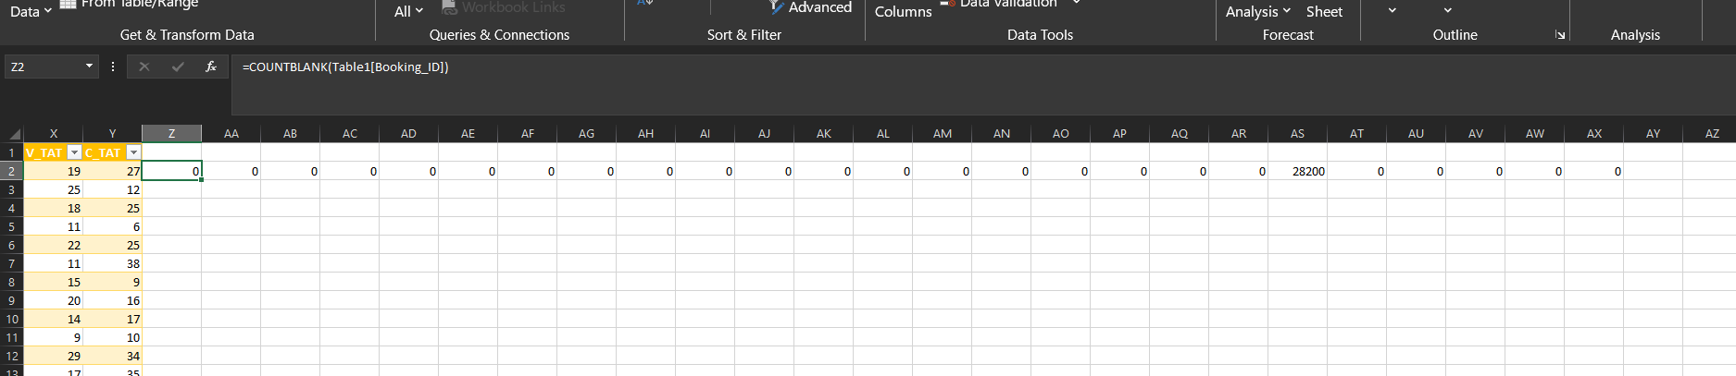

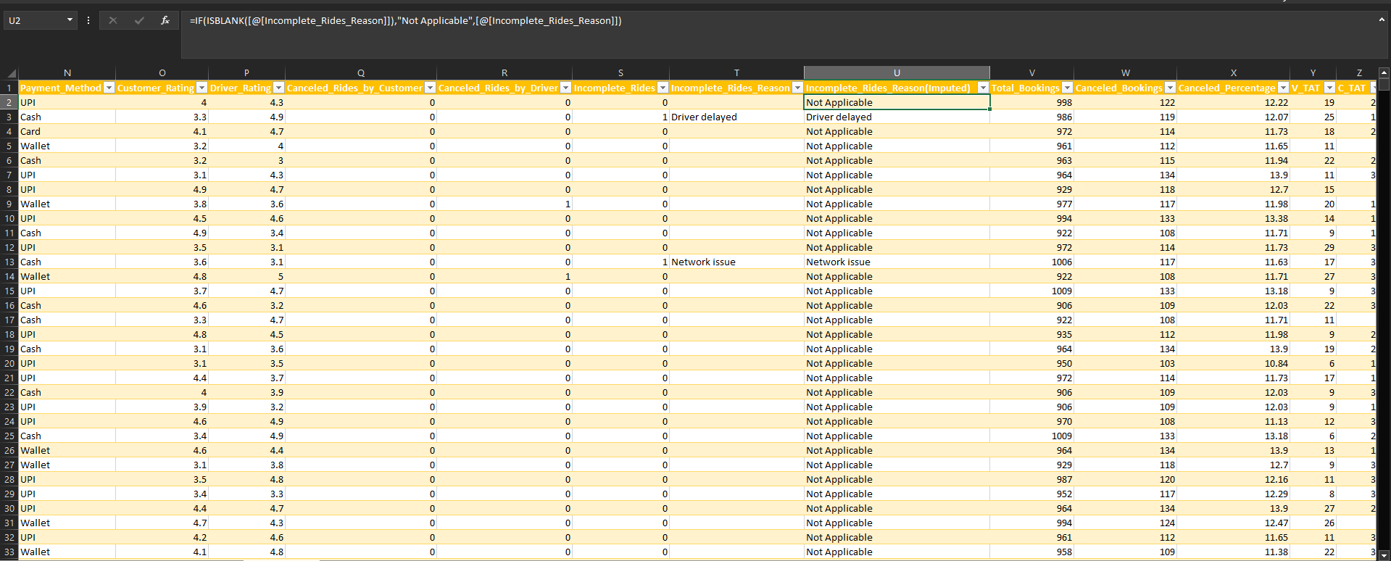
Duplicate Value Check

Duplicate values were checked at both the row level and the Booking_ID level. A row-wise duplicate check was performed to identify any completely repeated records, while the Booking_ID column was separately validated to ensure that each booking had a unique identifier. This helped ensure data integrity and prevented duplicate bookings from influencing the analysis.

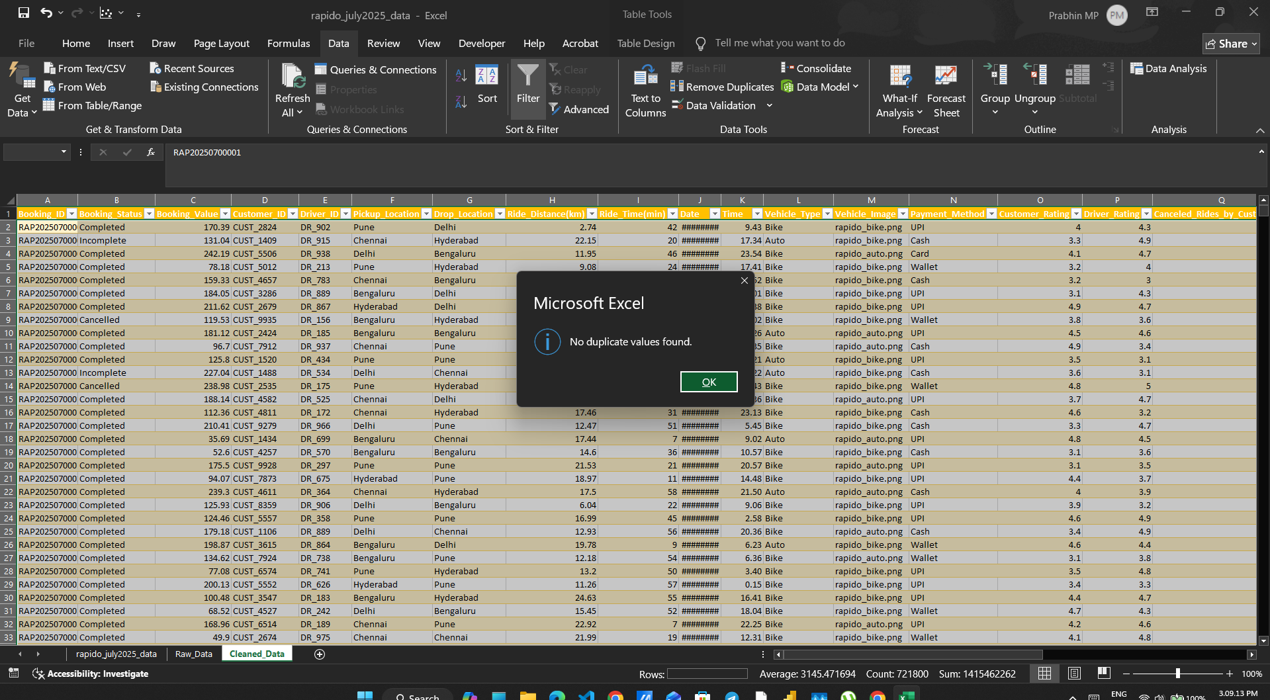

Date Transformation

The booking date field was transformed to support time-based analysis in Power BI.

Separation of Date Components

The original date was separated into three components:

- Date (Day)
- Month
- Year

Flash Fill in Excel was used to populate the separated date components efficiently.

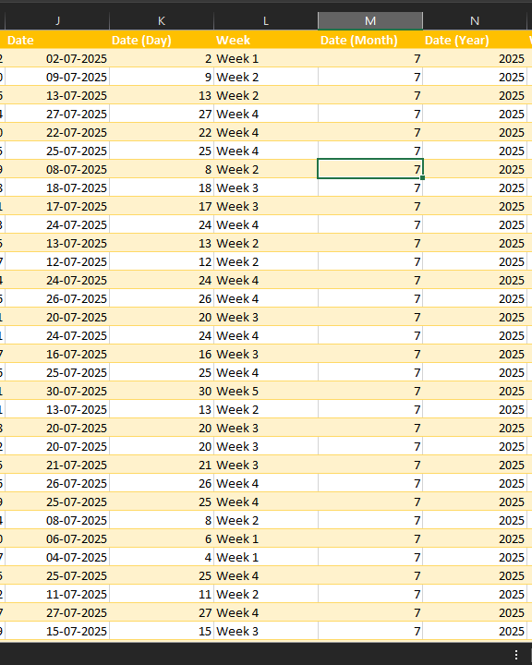

Week Classification

The Date (Day) column was then used to classify each booking into weekly periods within the month.
The following formula was used:

=IF([@[Date (Day)]]<8,"Week 1",
IF([@[Date (Day)]]<15,"Week 2",
IF([@[Date (Day)]]<22,"Week 3",
IF([@[Date (Day)]]<29,"Week 4","Week 5"))))

This classified the dates as:

Date | Week
1–7 | Week 1
8–14 | Week 2
15–21 | Week 3
22–28 | Week 4
29–31 | Week 5

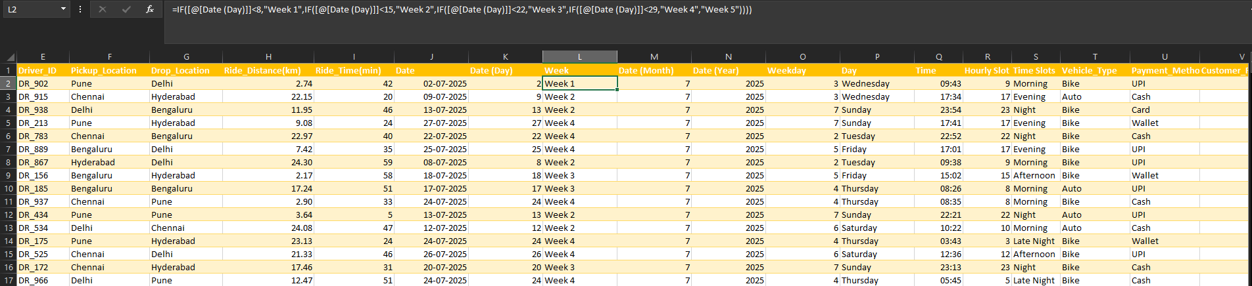

Weekday Identification
The WEEKDAY function was used with the 2 return type so that Monday = 1 and Sunday = 7.
The following formula was used:
=WEEKDAY([@Date],2)
Then a separate IF formula was then used to convert the weekday number into the corresponding weekday name:

The following formula was used:

=IF([@Weekday]=1,"Monday",
IF([@Weekday]=2,"Tuesday",
IF([@Weekday]=3,"Wednesday",
IF([@Weekday]=4,"Thursday",
IF([@Weekday]=5,"Friday",
IF([@Weekday]=6,"Saturday","Sunday"))))))
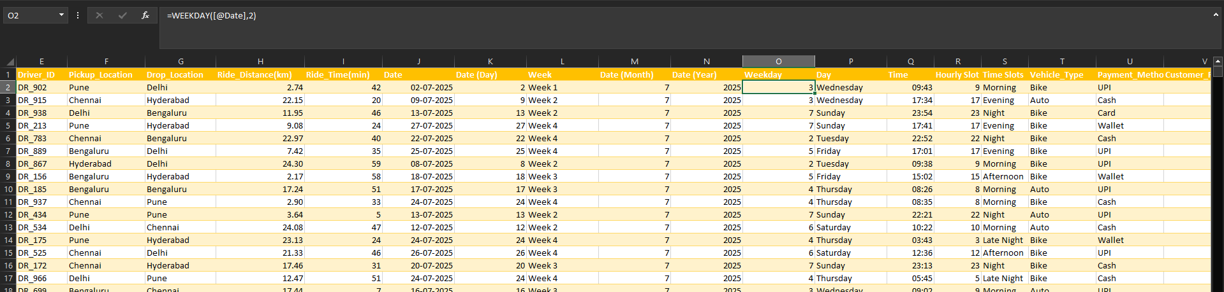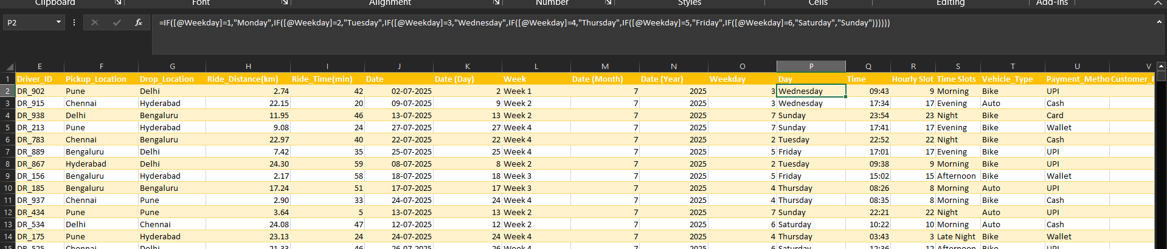

Time-Based Transformation

The booking time was transformed into additional fields to support time-based analysis in Power BI.
Hourly Slot
The HOUR function was used to extract the hour from the original Time field.
=HOUR([@Time])
This created the Hourly Slot field, with values ranging from 0 to 23, representing the hour during which the booking was made.

Time Slot

The hourly values were then grouped into broader time periods using the following classification:
=IF([@[Hourly Slot]]<6,"Late Night",
IF([@[Hourly Slot]]<12,"Morning",
IF([@[Hourly Slot]]<16,"Afternoon",
IF([@[Hourly Slot]]<20,"Evening","Night"))))

The resulting classification was:

Hour | Time Slot
00:00–05:59 | Late Night
06:00–11:59 | Morning
12:00–15:59 | Afternoon
16:00–19:59 | Evening
20:00–23:59 | Night

This transformation enabled the booking data to be analysed at both hourly level and broader time-period level.
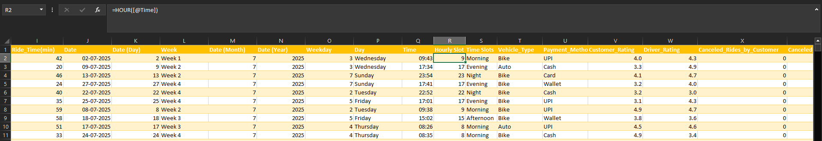
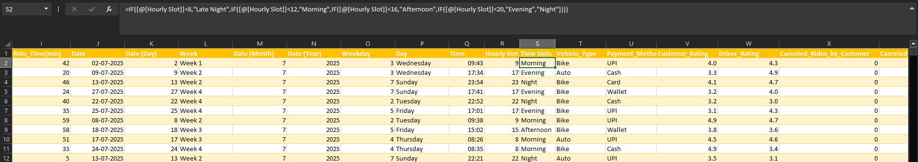

Data Validation

Validation checks were performed to ensure that the booking statuses were consistent.

The final dataset contained:

Booking Status | Number of Bookings
Completed | 24,641
Cancelled | 3,559
Incomplete | 1,800
Total | 30,000

This confirms that the three booking-status categories account for the complete dataset.

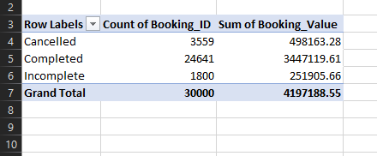
Creation of Final Analysis Dataset

After completing the required data cleaning and transformations, a separate worksheet named Rapido July Data was created as the final analysis dataset for Power BI.

VLOOKUP and INDEX-MATCH functions were used to retrieve and combine the required fields from the processed source data and construct the final analysis-ready dataset.

The Booking_ID was used as the lookup value/key to retrieve the corresponding information for each booking from the processed data.

The Rapido July Data sheet was then used as the source dataset for Power BI, ensuring that the dashboard was built using the cleaned and transformed data rather than the original raw data.

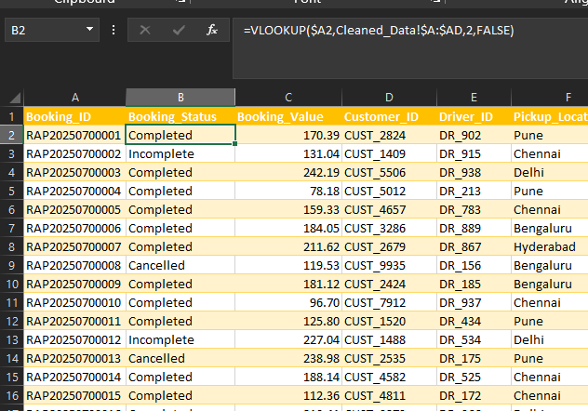
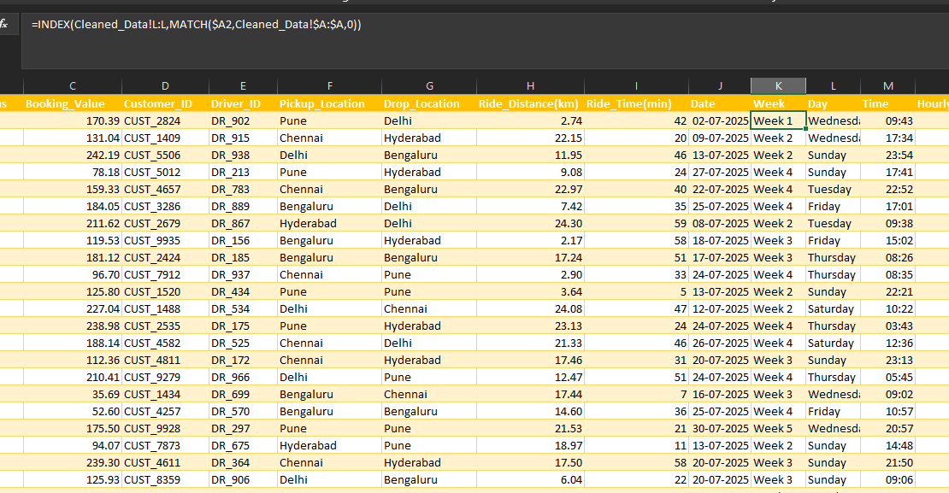

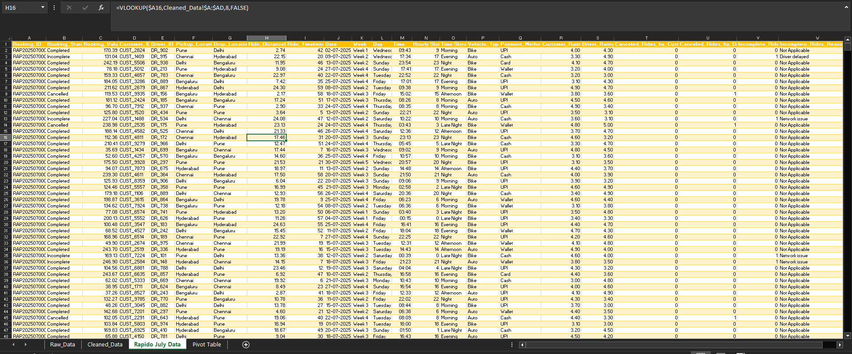

Data Type and Format Validation

After creating the final Rapido July Data worksheet, the data types and formats of the fields were reviewed to ensure that they were appropriate for analysis and visualization in Power BI.
The required formats were applied based on the nature of each field.
Eg:
- Booking Value → numeric format
- Ride Distance → numeric/decimal format
- Ride Time → numeric format (minutes)
- Date → date format
- Time → custom time format (hh:mm)
- Week → text format
- Hourly Slot → General
- Booking Status, Vehicle Type, Payment Method and Locations → text format
- Customer Rating and Driver Rating → numeric/decimal format
- Cancellation and Incomplete Ride indicators → General

Power BI Dashboard
The processed dataset was imported into Power BI to create an interactive dashboard titled:
Rapido Booking & Operations Analysis
The dashboard was designed around the major business questions identified during the analysis.
Key dashboard components
KPI Cards
- Total Bookings
- Total Booking Value
- Cancellation Rate
- Potential Value at Risk
Demand Analysis
- Daily Bookings & Booking Value
- Booking Demand by Hour
- Booking Demand by Time Slot
Location Analysis
- Booking Demand by Pickup Location
- Booking Demand by Drop Location
Vehicle Analysis
- Booking Demand by Vehicle Type
- Booking Value by Vehicle Type & Payment Method
Cancellation Analysis
- Customer vs Driver Cancellations
Incomplete Ride Analysis
- Incomplete Ride Reasons
Experience Analysis
- Average Customer Rating
- Average Driver Rating

Interactive Filters and Controls

To improve the interactivity and usability of the dashboard, multiple filters and interactive controls were incorporated.

The dashboard includes:

Booking Status slicer: Allows users to analyse Completed, Cancelled, Incomplete or All bookings.
Week filter: Allows users to analyse booking activity for a specific week.
Day filter: Allows users to analyse booking activity by day of the week.
Vehicle Type buttons slicer: Interactive buttons were incorporated for Bike and Auto, allowing users to focus the dashboard analysis on a specific vehicle type.

These interactive controls allow users to dynamically filter the dashboard and examine booking behaviour from different perspectives without requiring separate dashboards for each category.

KPI Cards

KPI Card | Definition | DAX Formula
Total Bookings | Count of all booking records | Total Bookings = COUNTA('Rapido July Data'[Booking_ID])
Total Booking Value | Sum of Booking Value for all bookings | Total Booking Value = CALCULATE(SUM('Rapido July Data'[Booking_Value]),ALL('Rapido July Data'[Booking_Value]))
Cancellation Rate | Cancelled bookings ÷ Total bookings | Cancellation Rate = [Cancelled Bookings]/[Total Bookings]
Potential Value at Risk | Cancelled Booking Value + Incomplete Booking Value | Potential Revenue at Risk = [Incomplete Booking Value]+[Cancelled Booking Value]  Incomplete Booking Value = CALCULATE(SUM('Rapido July Data'[Booking_Value]),'Rapido July Data'[Booking_Status]="Incomplete")  Cancelled Booking Value = CALCULATE(SUM('Rapido July Data'[Booking_Value]),'Rapido July Data'[Booking_Status]="Cancelled")
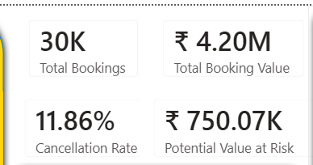

KPI cards were used to provide a high-level summary of the booking performance and booking value of the dataset. The cards were positioned at the top of the dashboard to ensure that the most important metrics were immediately visible to the user. Monetary values were formatted in Indian Rupees (₹), percentages were displayed using percentage formatting, and booking counts were displayed as whole numbers.

Demand Analysis
Daily Bookings & Booking Value

Component | Definition | DAX Formulas Used
Daily Bookings & Booking Value | Compares the number of bookings and total booking value for each day of July | Total Bookings = COUNTA('Rapido July Data'[Booking_ID])  Total Booking Value = CALCULATE(SUM('Rapido July Data'[Booking_Value]),ALL('Rapido July Data'[Booking_Value]))

Purpose of the Visual
A Line and Clustered Column Chart was used to display two related measures simultaneously—Total Bookings and Total Booking Value—across the 31 days of July.
The clustered columns show the daily booking volume, while the line represents the corresponding booking value. This combination allows variations in booking volume and booking value to be compared across the same time period.
Business Question
How does daily booking volume and booking value vary throughout the month?
Why this visual was selected
Using columns and a line in the same visual makes it easier to identify days where:
- Booking volume is high but booking value is relatively low.
- Booking volume is low but booking value is relatively high.
- Both booking volume and booking value increase together.
- Significant fluctuations occur during the month.

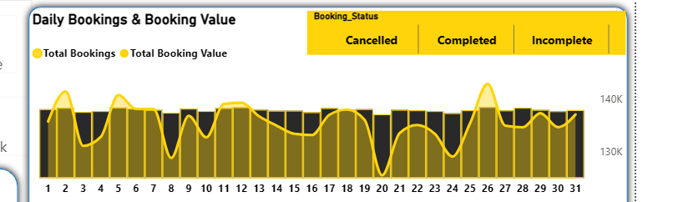

Booking Demand by Hour

Component | Definition | DAX Formulas Used
Booking Demand by Hour | Counts the number of bookings for each hourly slot from 0–23 | Total Bookings = COUNTA('Rapido July Data'[Booking_ID])

Purpose of the Visual
An Area Chart was used to visualize booking demand across the 24 hours of the day. The Hourly Slot field, ranging from 0 to 23, was placed on the X-axis, while the total number of bookings was used on the Y-axis. The filled area makes fluctuations in demand throughout the day visually prominent.
Business Question
Which hours of the day experience the highest and lowest booking demand?
Why this visual was selected
An Area Chart was selected because the objective is to highlight the continuous pattern and fluctuations in booking demand throughout the day.
It helps identify:
- Peak booking hours
- Low-demand hours
- Changes in demand throughout the day
- Periods where additional vehicle availability may be required
Business Use
The hourly demand pattern can support driver allocation and fleet planning, allowing the business to identify periods of higher demand and potentially improve vehicle availability during those periods.

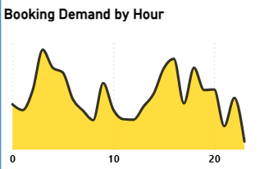

Booking Demand by Time Slot

Component | Definition | DAX Formulas Used
Booking Demand by Time Slots | Counts the total number of bookings within each predefined time period | Total Bookings = COUNTA('Rapido July Data'[Booking_ID])

Purpose of the Visual
A Treemap was used to compare booking demand across the five predefined time slots: Late Night, Morning, Afternoon, Evening and Night. The size of each rectangle represents the number of bookings in that time period, allowing the relative demand across different periods to be compared quickly.
Business Question
Which time slots experience the highest and lowest booking demand?
Why this visual was selected
A Treemap was selected because it provides a compact visual comparison of multiple categorical time periods. The varying rectangle sizes make differences in booking volume easy to identify without requiring a large amount of dashboard space.
Business Use
The visual can help identify periods of higher booking demand and support driver availability and resource allocation planning.
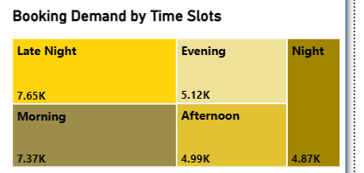
Booking Demand by Pickup Location

Component | Definition | DAX Formulas Used
Booking Demand by Pickup Location | Counts total bookings for each pickup location | Total Bookings = COUNTA('Rapido July Data'[Booking_ID])

Purpose of the Visual
A clustered column chart was used to compare the number of bookings originating from different pickup locations. This helps identify locations with relatively higher or lower booking demand.
Business Question
Which pickup locations generate the highest booking demand?

Booking Demand by Drop Location

Component | Definition | DAX Formulas Used
Booking Demand by Drop Location | Counts total bookings for each drop location | Total Bookings = COUNTA('Rapido July Data'[Booking_ID])

Purpose of the Visual
A clustered bar chart was used to compare booking demand across different drop locations. The horizontal orientation makes location names easier to read and provides a clear ranking of destinations.
Business Question
Which drop locations receive the highest booking demand?
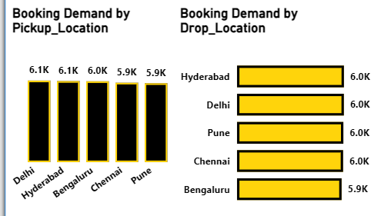

Booking Demand by Vehicle Type

Component | Definition | DAX Formulas Used
Booking Demand by Vehicle Type | Counts the total number of bookings for each vehicle type | Total Bookings = COUNTA('Rapido July Data'[Booking_ID])

Purpose of the Visual
A Donut Chart was used to show the distribution of total bookings between the available vehicle types. The size of each segment represents the proportion of bookings associated with each vehicle type.
Business Question
Which vehicle type is most frequently booked?
Business Use
The distribution can support vehicle allocation and operational planning, particularly when considering the relative demand for Bike and Auto services.
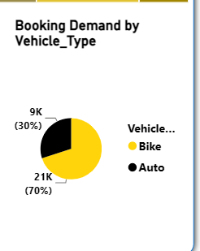

Cancellation Analysis
Customer vs Driver Cancellations

Component | Definition | DAX Formulas Used
Customer vs Driver Cancellations | Compares the number of cancellations initiated by customers with those initiated by drivers | Customer Cancellations = CALCULATE(COUNTA('Rapido July Data'[Canceled_Rides_by_Customer]),'Rapido July Data'[Canceled_Rides_by_Customer]=1)  Driver Cancellations = CALCULATE(COUNTA('Rapido July Data'[Canceled_Rides_by_Driver]),'Rapido July Data'[Canceled_Rides_by_Driver]=1)

Purpose of the Visual
A Donut Chart was used to compare cancellations initiated by customers and drivers. The chart displays both the absolute number and percentage contribution of each cancellation category, making the relative contribution of customer and driver cancellations easy to compare.

Business Question
Are cancellations more frequently initiated by customers or drivers?
Business Use
This analysis can help the business distinguish between customer-driven and driver-driven cancellation behaviour. Since customer cancellations represent the larger share, further analysis of customer cancellation reasons and the conditions surrounding these bookings could help identify opportunities to reduce cancellations.

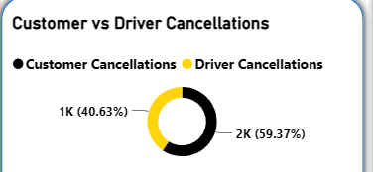

Incomplete Ride Reasons

Component | Definition | DAX Formulas Used
Incomplete Ride Reasons | Counts incomplete bookings by their incomplete-ride reason | -

Purpose of the Visual
A Matrix Table visual was used to provide a detailed breakdown of incomplete bookings according to the recorded/imputed reason. The table allows the individual reasons to be compared using their respective booking counts.
Business Question
What are the main reasons for bookings becoming incomplete?
Business Use
The analysis can help identify areas for operational improvement. Network reliability, driver punctuality and customer-related issues can be investigated further to reduce the number of incomplete bookings and the associated potential value at risk.
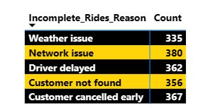

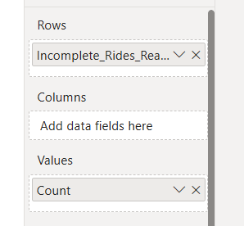

Booking Value by Vehicle Type & Payment Method

Component | Definition | DAX Formulas Used
Booking Value by Vehicle Type & Payment Method | Calculates total booking value across each vehicle type and payment method | Total Booking Value = CALCULATE(SUM('Rapido July Data'[Booking_Value]),ALL('Rapido July Data'[Booking_Value]))

Purpose of the Visual
A Ribbon Chart was used to visualize the flow of booking value from Vehicle Type to Payment Method.
Business Question
How is booking value distributed across vehicle types and payment methods?
Why this visual was selected
The Ribbon Chart was selected because it is particularly suitable for showing relationships and flows between two categorical dimensions. In this case, it allows the relationship between vehicle type and payment method to be viewed within a single visual.
It helps identify:
- Which vehicle type contributes more booking value.
- Which payment methods are associated with higher booking value.
- How booking value flows from each vehicle type to different payment methods.
Business Use
This analysis can help the business understand the relationship between vehicle preference and payment behaviour, which may support payment-service planning.

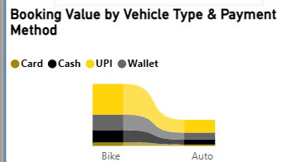

Customer and Driver Ratings

Component | Definition | DAX Formulas Used
Average Customer Rating | Calculates the average of all available customer ratings | Average Customer Rating = CALCULATE(AVERAGE('Rapido July Data'[Customer_Rating]))  Avg Cust: Rating = REPT("★",ROUND([Average Customer Rating],0))
Average Driver Rating | Calculates the average of all available driver ratings | Average Driver Rating = CALCULATE(AVERAGE('Rapido July Data'[Driver_Rating]))  Avg Driver Rating = REPT("★",ROUND([Average Driver Rating],0))

Purpose
Two rating indicators were incorporated into the dashboard to provide a quick overview of customer satisfaction and driver performance.
Business Questions
What is the overall average customer rating?
What is the overall average driver rating?
Business Use
These KPIs provide a high-level service-quality indicator. They can be used as a baseline for further analysis of whether factors such as vehicle type, location, booking status or demand periods are associated with differences in customer or driver ratings.
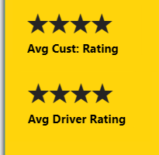

Interactive Filters and Controls
Vehicle Type Button Slicer
Purpose
Image-based interactive buttons were incorporated for Bike and Auto to allow users to filter the dashboard according to vehicle type.
Business Question
How does booking performance change when analysing Bike and Auto bookings separately?
Business Use
The vehicle buttons allow users to compare demand, booking value, cancellations and other dashboard metrics between the two vehicle categories without creating separate dashboards.

Booking Status Slicer
Purpose
A slicer was incorporated to allow users to dynamically filter the dashboard based on the outcome of a booking.
The available options are:
- Cancelled
- Completed
- Incomplete
Business Question
How does booking performance differ across completed, cancelled and incomplete bookings?
Business Use
This control allows users to isolate a particular booking status and investigate its demand, location, vehicle and booking-value patterns.

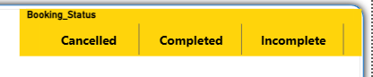

To maintain the integrity of the KPI and diagnostic visuals, the interaction of the Booking Status selector was disabled for selected visuals.
The Booking Status selector does not influence:
- Cancellation Rate KPI
- Potential Value at Risk KPI
- Incomplete Ride Reasons
- Customer vs Driver Cancellations
The selector continues to interact with the other relevant dashboard visuals.
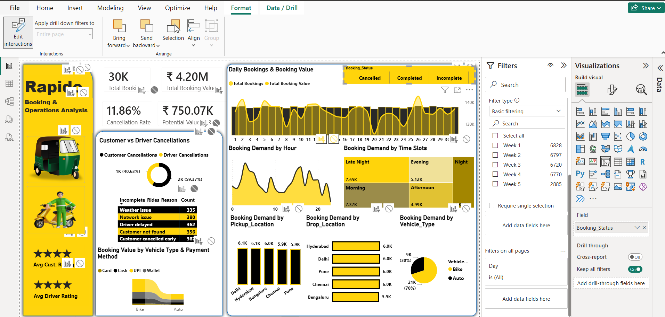

Week Filter
Purpose
The Week filter allows users to analyse booking activity for a specific week of the month rather than viewing the entire July dataset.
Business Question
How does booking performance vary across different weeks of the month?
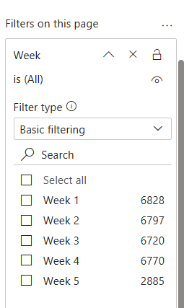
Day Filter
Purpose
A Day filter was incorporated at the report level to allow users to analyse the dashboard for a particular day of the week.
Business Question
How does booking behaviour change across different days of the week?
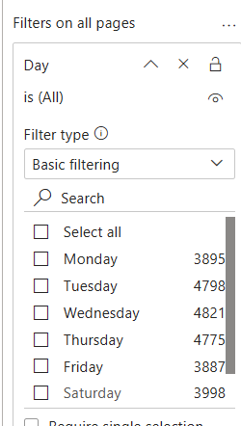

DASHBOARD
RAPIDO - Booking & Operations Analysis

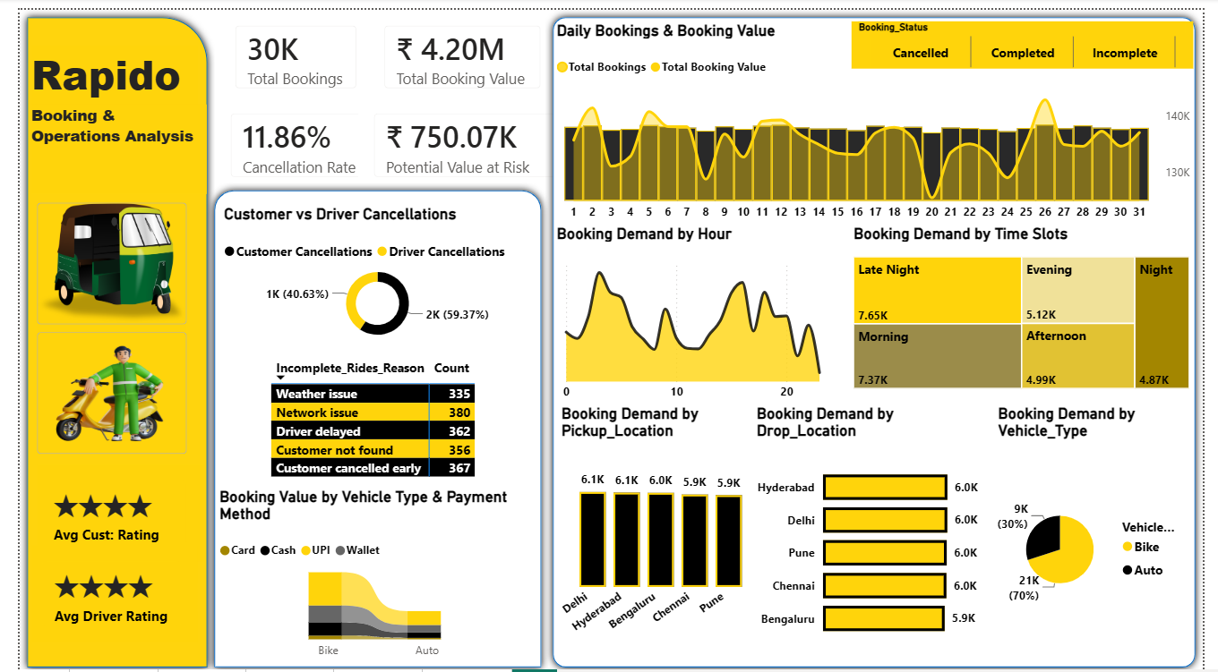

Key Insights.
Booking Performance

Out of the 30,000 bookings, 24,641 (82.14%) were completed, 3,559 (11.86%) were cancelled, and 1,800 (6.00%) were incomplete.

This indicates that the majority of bookings were successfully completed, while 17.86% of bookings did not result in a completed ride.

Business implication: There is an opportunity to improve booking completion by addressing the causes of cancellations and incomplete rides.

Booking Value and Potential Value at Risk

The total booking value recorded in the dataset is approximately ₹4.20 million. Completed bookings account for approximately ₹3.45 million, while approximately ₹750.07 thousand is associated with cancelled and incomplete bookings.

The ₹750.07K is classified as Potential Value at Risk.

Business implication: Reducing unsuccessful bookings could potentially protect a significant amount of booking value.

Customer vs Driver Cancellations

Customer cancellations account for 59.37% of the cancellation activity, compared with 40.63% for driver cancellations.

The dashboard records approximately:

2,113 customer cancellations
1,446 driver cancellations

Business implication: Customer cancellation behaviour should be investigated further, while driver-side cancellations also require operational monitoring.

Reasons for Incomplete Rides

There were 1,800 incomplete bookings. The main recorded/imputed reasons were:

Reason | Count
Network issue | 380
Customer cancelled early | 367
Driver delayed | 362
Customer not found | 356
Weather issue | 335

Network issues were the most frequent reason, although the difference between the categories was relatively small.

Business implication: Incomplete rides are caused by multiple factors rather than one single dominant problem.

Peak Booking Time Slots

The time-slot analysis identified Late Night as the highest-demand period with approximately 7.65K bookings, followed by Morning with 7.37K bookings.

Time Slot | Bookings
Late Night | 7.65K
Morning | 7.37K
Evening | 5.12K
Afternoon | 4.99K
Night | 4.87K

Business implication: Driver availability should be planned carefully around high-demand periods, particularly Late Night and Morning.

Vehicle Type Demand

The vehicle analysis shows a clear preference for Bikes:

Bike: 21K bookings (70%)
Auto: 9K bookings (30%)

Bike bookings are therefore more than twice the volume of Auto bookings.

Business implication: Driver allocation should reflect the significantly higher demand for Bike services.

Location Demand

Booking demand is relatively evenly distributed across the five pickup and drop locations.

Pickup demand ranges from approximately 5.9K to 6.1K, while drop-location demand ranges from approximately 5.9K to 6.0K.

Business implication: No single location dominates booking demand in this dataset. Resource allocation should therefore consider additional factors such as time, cancellations and booking value rather than relying only on total booking volume.

Customer and Driver Ratings

The dashboard reports:

Average Customer Rating: 4.01
Average Driver Rating: 4.00

Both ratings are approximately 4 out of 5.

Business implication: Overall ratings indicate a generally positive service experience, while further analysis could identify locations, vehicle types or time periods associated with lower ratings.

Hourly Demand Variation

The hourly demand analysis shows noticeable fluctuations throughout the 24-hour period, with several peaks and lower-demand periods.

Business implication: Driver allocation should consider hourly demand rather than relying only on overall daily booking averages.

Business Actions and Recommendations

Based on the above findings, the following actions are recommended.

Key Finding | Recommended Action | Expected Outcome
17.86% of bookings are cancelled or incomplete | Analyse unsuccessful bookings by reason, time and location | Improve booking completion
₹750.07K potential value at risk | Investigate which unsuccessful bookings can potentially be recovered | Reduce potential value leakage
Customer cancellations represent 59.37% | Analyse customer cancellation triggers and booking conditions | Reduce customer cancellations
Network issue is the largest incomplete-ride reason | Investigate network and technical reliability | Reduce technology-related incomplete rides
Driver delays contribute significantly to incomplete rides | Monitor driver arrival performance and improve allocation | Improve service reliability
Late Night and Morning have highest demand | Increase driver availability during these periods | Better demand coverage
Bike accounts for 70% of bookings | Prioritize Bike driver availability | Improve vehicle utilization
Demand is relatively balanced across locations | Avoid excessive resource concentration in one location | More balanced resource allocation
Ratings are around 4.0 | Maintain service quality and investigate lower-rated segments | Sustain customer satisfaction
Hourly demand fluctuates | Use hourly demand patterns for scheduling | Improve operational efficiency

Conclusion

This project analysed 30,000 Rapido booking records to understand booking performance, booking value, demand patterns, vehicle usage, location demand, cancellations, incomplete rides and customer and driver ratings.

The analysis found that 82.14% of bookings were completed, while 11.86% were cancelled and 6.00% were incomplete. The dataset recorded approximately ₹4.20 million in total booking value, of which approximately ₹3.45 million was associated with completed bookings. Approximately ₹750.07K was identified as potential value at risk from cancelled and incomplete bookings.

Customer cancellations represented the larger share of cancellation activity at 59.37%, while network issues were the most frequently recorded reason for incomplete rides. Demand was highest during Late Night and Morning, while Bike represented approximately 70% of all bookings.

The analysis also showed that booking demand was relatively evenly distributed across the five locations, and both customer and driver ratings were approximately 4.0, indicating a generally positive overall service experience.

The findings suggest that the main opportunities for operational improvement are reducing cancellations and incomplete rides, improving driver availability during high-demand periods, addressing network-related issues and optimizing vehicle allocation according to demand.

